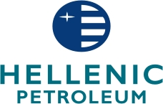

Purchase of Own Shares

HELLENIC PETROLEUM S.A. announces that on 14 July 2017, the Company purchased, through Εurobank Equities, 59,000 common own shares, against an average purchase price per share of euro 8.278072 and a total purchase price of euro 488,406.25, in implementation of the decision dated 6th July 2017 of the Extraordinary General Meeting of Shareholders and the resolution dated 10th July 2017 of the Board of Directors, pursuant to article 16 para. 1 of Law 2190/1920, article 5 of Regulation (EU) No 596/2014 of the European Parliament and of the Council and of the Commission Delegated Regulation (EU) 2016/1052.

Maroussi, 17/7/2017

